Crop Protection

## Boom Sprayer

**Category:** Fertilization & Irrigation

**Tags:** PTO Operated Spraying

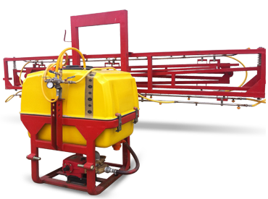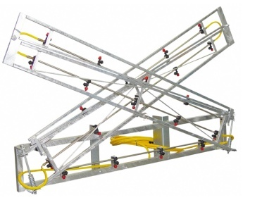

## Description

Boom sprayer connected to the three point linkage of tractor and getting drive from (P.T.O) is used for multipurpose plant protection. With these sprayers all kind of field crops could be sprayed. The PTO pump can be detached from sprayer and used as a backup pump if needed. It includes full UV & chemical resistant virgin polyethylene tank and its solid colour means no algae growth inside the tank.

|  |  |  |
| --- | --- | --- |
| Specifications | | |
| Capacity | 500 ltr | 600 ltr |
| Tank Material | polyethylene | |
| Pump Type | PTO pump | |
| Boom Span | 55 ft / 18.5 m | |
| Boom Height | Adjustable up to 60'' | |
| No. of Booms | 3 | |
| No. Of Nozzles | 38 | 40 |
| PTO rpm | 540 | |
| Covering Efficiency | ~ 99% | |
| Power Requirement | 50-65 HP | 65- 75 HP |

|  |  |
| --- | --- |
|  |  |
|  |  |
|  |  |
|  |  |
|  |  |
|  |  |
|  |  |
|  |  |